**BANKING MANAGEMENT SYSTEM**

**PBL REPORT**

**(17CSC07 & DATABASE MANAGEMENT SYSTEM)**

***Submitted by***

**SELVAGANESH K (17CS091)**

**MAHADEVA PRASAD L (17CSL05)**

**NAVEENKANTH A (17CSL06)**

***in partial fulfillment for the award of the degree of***

**BACHELOR OF ENGINEERING IN**

**COMPUTER SCIENCE AND ENGINEERING**



**NANDHA ENGINEERING COLLEGE**

**ERODE - 638052**

(Autonomous)

(Affiliated to Anna University, Chennai)

**APRIL 2019**

**NANDHA ENGINEERING COLLEGE**

(Autonomous)

(Affiliated to Anna University, Chennai)

**BONAFIDE CERTIFICATE**

Certified that this Report titled “**BANKING MANAGEMENT SYSTEM**” is the bonafide work of **SELVA GANESH K(17CS091), MAHADEVA PRASAD L (17CSL05), NAVEENKANTH A (17CSL05)** who carried out the work under my supervision.

**Signature of the HOD Signature of the Supervisor**

Mr. K. GUNASEKAR M.E., Mr.V.MANIMAARAN M.E.(Ph.D)

Associate Professor& Head Assistant Professor

Department of CSE Department of CSE

Nandha Engineering College Nandha Engineering College

Erode– 638052 Erode– 638052

Submitted for End Semester PBL Review Examination held on …………………..

**EXAMINER**

**TABLE OF CONTENTS**

|  |  |  |  |
| --- | --- | --- | --- |
| **CHAPTER No.** | **TITLE** | **PAGE No.** |  |
|  | **ABSTRACT** | **4** |  |

1. **INTRODUCTION 4**

**2. THEORITICAL BACKGROUND 5** 2.1 Techniques Implemented **5** 2.1.1 Netbeans IDE 8.2  **5**

**3. PROJECT DESCRIPTION 8** 3.1 Development Platform 3.1.1 Netbeans IDE  **9** 3.1.2 MySQL  **10**

**4. PROJECT IMPLEMENTATION 11** 4.1 Module Flowchart **11**

**5. SCREENSHOTS 13**

**6. CONCLUSION AND FUTURE WORK 16**

**APPENDICES 17**

**REFERENCES 49**

**ABSTRACT**

The Bank Account Management System is an application for maintaining a person's account in a bank. In this project I tried to show the working of a banking account system and cover the basic functionality of a Bank Account Management System. To develop a project for solving financial applications of a customer in banking environment in order to nurture the needs of an end banking user by providing various ways to perform banking tasks. The main aim of this project is to develop software for Bank Account Management System. This project has been developed to carry out the processes easily and quickly, which is not possible with the manuals systems, which are overcome by this software. This project is developed using JAVA language and MYSQL use for database connection. Organization need to effectively define and manage requirements to ensure they are meeting needs of the customer, while proving compliance and staying on the schedule and within budget. The impact of a poorly expressed requirement can bring a business out of compliance or even cause injury or death. Requirements definition and management is an activity that can deliver a high, fast return on investment.

**CHAPTER 1**

**INTRODUCTION:**

The main object of this system is to provide a secure system. Our system is password protected and it only allows authorized user to access various functions available in the system.

 It will Reduced manual work as most of the work done by computer. As all the manual work will be done automatically so it will increase work speed and reduce time consumption to complete any bank related work. It will also increase the work efficiency as few employees can handle more customers.  This will reduced the manual workload and give information instantly.

The Project Banking system has been made to automate the Banking system. Using this bank management system user can check his account detail online like balance in account, bank statement etc.  The Administrator can check bank account with a login can work out with A/C holders from their accounts. This system is also help bank user to create New account easily. The project makes a sincere effort to provide all the below-mentioned features to meet the requirements of the bank.

**CHAPTER 2**

**THEORETICAL BACKGROUND**

**2.1 Techniques implemented**

**2.1.1 NETBEANS IDE 8.2**

**INTRODUCTION:**

**Paradigm :** Structured, imperative, object-oriented, event-driven, task- driven, functional, generic, reflective, concurrent.

**Family :** JAVA

**Designed by :** Microsoft

**First appeared :** 2000

**Typing discipline :** Static, dynamic, strong, safe, nominative, partially inferred

**Platform :** Common Language Infrastructure License

**Mono compiler :** JVM

**Libraries** : MySQL connector.jar, JDK1.8

**Extensions :** .java

**Design goals**

* The language is intended to be a simple, modern, general-purpose, object-oriented programming language.
* The language, and implementations thereof, should provide support for software engineering principles such as strong type checking, array bounds checking, detection of attempts to use uninitialized variables, and automatic garbage collection. Software robustness, durability, and programmer productivity are important.
* The language is intended for use in developing software components suitable for deployment in distributed environments.
* The project has a very vast scope in future. The project can be implemented on intranet in future.
* Project can be updated in near future as and when requirement for the same arises, as it is very flexible in terms of expansion. With the proposed software of database Space Manager ready and fully functional the client is now able to manage and hence run the entire work in a much better, accurate and error free manner.

**SIMPLE EXAMPLE**

Import java.io.*;

Import java.util.*;

public class Example

{

public static void Main(String args[])

{

Int a=5;

System.out.println(a);

}

}

**OUTPUT**

5

**ADVANTAGES**

* First, it integrates well with Windows. You don't need any special configurations to get a java program to run in your Windows environment. Whether it's a web application, a Windows service, or a desktop app, java programs are easily deployed on the network. As long as the target server or workstation supports, your java program deployment should be a smooth transition from development to production.
* Next, java is easy to find additional developers whether it's for a contract or full-time basis. If your business grows and you need additional developers, java is one of the common languages programmers learn. It also has very close syntax with Java, so you can usually find a developer who understands Java (for frontend) and MySQL (for backend services) at the same time.
* If you have a team of developers, Microsoft has made it easy for a team to work together on one project. netbeans has integrated tools for change control and code merges. Microsoft offers Team Foundation Server versions of its software and Enterprise options for large development teams.
* Finally, java is a compiled language, which means that the code stored on a public-facing server is in binary form. If your server gets hacked, the hacker doesn't automatically have access to your source code. With other common languages such as PHP, the hacker gains access to source code, which could then give him access to database passwords. With java, the hacker must decompile or "crack" your software before he can see the critical components.

**DISADVANTAGES**

* In the previous section, compiling the code was mentioned as a "pro." It is an advantage, but compiling code also has some disadvantages. It's much more difficult to work with since your code must be compiled each time you make even a minor change. If you change one letter in your code, you must recompile the whole application and deploy it again. This often leads to added bugs if a minor change isn't thoroughly tested.
* Since java is a part of the netbeans IDE, the server running the application must be Windows. In other words, any .java application needs a Windows platform to execute. Many new companies work with Linux servers since it's a much cheaper environment. You need Windows hosting to run a java application.
* Microsoft stops supporting older netbeans IDE after a few operating systems upgrades. For instance, older Windows 2000 servers can only support netbeans IDE 8.7.3. While having an old operating system installed seems like a mistake, many enterprise organizations keep older operating systems because of the many problems that an upgrade can bring to the platform

**CHAPTER 3**

**PROJECT DESCRIPTION:**

This project “BANKING MANAGEMENT SYSTEM” is developed in the environment of netbeans IDE. Where the frontend of the application is designed in netbeans IDE and the backend is programmed in MySQL. Here we use MySQL client for Database connection. Which is used to view, insert, update, delete the data values which we run in the application. These data values are stored in the MySQL database and can be retrieved later.

This application is mainly focused to work in the platform of Microsoft Windows operating system. To run this application there is no need of any installation process.

* Click on Login to enter into the Home Page.
* Fill the your details in username and password field
* If you entered wrong username or password the “username and password not matched” message will be thrown.
* In that case click Reset button then fill your details
* Fill your Account Number and IFSC code
* If you entered wrong Account Number or IFSC “invalid user “ the message will be thrown. Then reset and fill the details
* You can create new user in the create new account form
* If the details given is matched, then your personal details will be shown

You will see the transactions details will be shown

**3.1 DEVELOPMENT PLATFORM**

**3.1.1 .Netbeans IDE**

**Developed by** : Oracle Corporation

**Stable release** : 8.0.2

**Operating system** : Windows 98 or later, Windows NT 4.0 or later

**License** : Mixed; see § Licensing

**Initial** **release** **date** : 27 November 2008

**Netbeans IDE**

NetBeans IDE is the official IDE for Java 8. With its editors, code analyzers, and converters, you can quickly and smoothly upgrade your applications to use new Java 8 language constructs, such as lambdas, functional operations, and method references.

Batch analyzers and converters are provided to search through multiple applications at the same time, matching patterns for conversion to new Java 8 language constructs.

With its constantly improving Java Editor, many rich features and an extensive range of tools, templates and samples, NetBeans IDE sets the standard for developing with cutting edge technologies out of the box.

## Definition - What does Integrated Development Environment (IDE) mean?

An Integrated Development Environment (IDE) is an application that facilitates application development. In general, an IDE is a graphical user interface (GUI)-based workbench designed to aid a developer in building software applications with an integrated environment combined with all the required tools at hand.

Most common features, such as debugging, version control and data structure browsing, help a developer quickly execute actions without switching to other applications. Thus, it helps maximize productivity by providing similar user interfaces (UI) for related components and reduces the time taken to learn the language. An IDE supports single or multiple languages.

## Techopedia explains Integrated Development Environment (IDE)

The concept of IDE evolved from simple command based software which was not as useful as menu-driven software. Modern IDEs are mostly used in the context of visual programming, where applications are quickly created by moving programming building blocks or code nodes that generate flowchart and structure diagrams, which are compiled or interpreted.

Selecting a good IDE is based on factors, such as language support, operating system (OS) needs and costs associated with using the IDE etc.

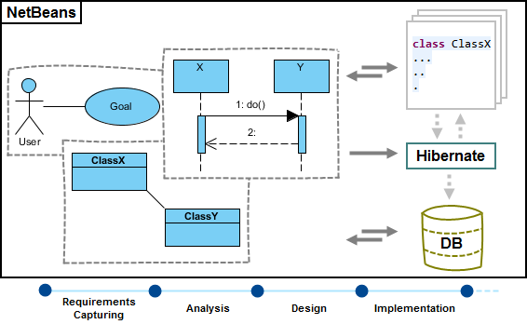

End users of the application benefit from pluggable applications because these enable them to install modules into their running applications.

NetBeans modules can be installed, uninstalled, activated, and deactivated at runtime, thanks to the runtime container.

The NetBeans Platform provides an infrastructure for registering and retrieving service implementations, enabling you to minimize direct dependencies between individual modules and enabling a loosely coupled architecture (high cohesion and low coupling).

The NetBeans Platform provides a virtual file system, which is a hierarchical registry for storing user settings, comparable to the Windows Registry on Microsoft Windows systems. It also includes a unified API providing stream-oriented access to flat and hierarchical structures, such as disk-based files on local or remote servers, memory-based files, and even XML documents.

**3.1.2 MySQL**

MySQL is an open-source relational database management system. Its name is a combination of "My", the name of co-founder Michael Widenius's daughter, and "SQL", the abbreviation for Structured Query Language.

**CHAPTER 4**

**4.1 MODULE FLOW CHART**

**Login**

**UserLogin**

**create**

**Account Details**

**Transaction details**

**LogOut**

**MODULE DESCRIPTION:**

**LOGIN:**

A **login**, logging in or logging on is the entering of identifier information into a system by a user in order to access that system (e.g., a computer or a website). ... A **login** generally requires the user to enter two pieces of information, first a user name and then a password.

**USER LOGIN:**

The **Login Module** is a portal **module** that allows **users** to type a **user** name and password to log **in**. This **module** can be placed on any **module** tab to allow **users** to log **in** to the system. ... The **module** is no longer available to **users** after they have logged **in**.

**REGISTRATION:**

Registration is one of the primary modules in any data management system. A patient's medical record management starts with registering a patient with the system. OpenMRS being a customizable and scalable solution to medical record management also requires a customizable patient registration system. Since every implementation of OpenMRS may be different on the type of information that it may require, it is extremely important to keep the registration module generalized in a way where it can be configured to take registration information about a patient according to the needs of the implementer.

**ACCOUNT DETAILS**:

Accounting software records and processes accounting transactions using modules that include accounts payable, accounts receivable, and payroll. Together, these modules function as an accounting information system. Below is a list of some of the typical accounting modules that are available in accounting software packages. You can use this list to see if a module might be useful for your business and then search for accounting software that has that module.

**TRANSCATION:**

The **Transaction Definition Module**. The purpose of the **Transaction Definition Module** is to provide the end user with an environment for defining business processes containing **transaction** control activities. The **module** consists of an Eclipse feature based on the Eclipse BPEL Designer

**LOGOUT:**

Loging out means to end access to a computer system or a website. Logging out informs the computer or website that the current user wishes to end the login session. **Log out** is also known as log off, sign off or sign out.

**CHAPTER 5**

**SCREENSHOTS:**

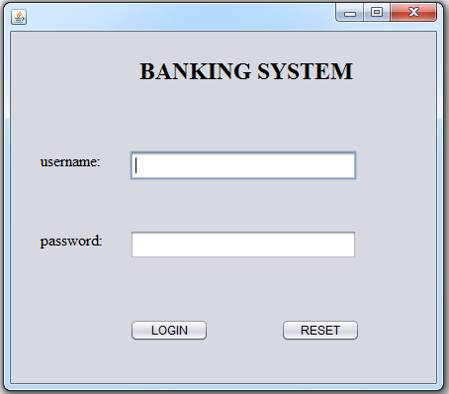

FIGURE 5.1

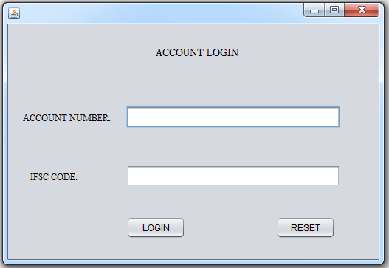FIGURE 5.2

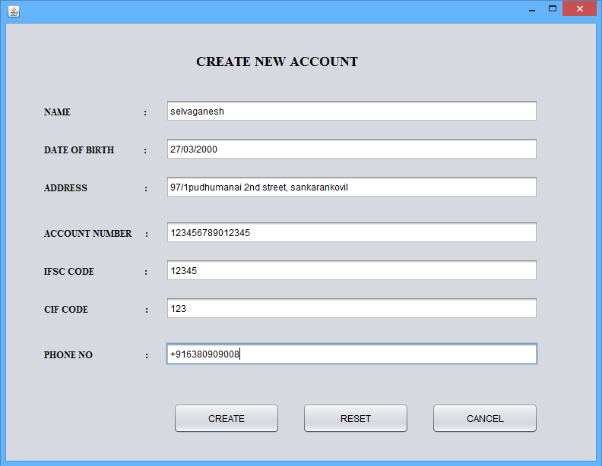

FIGURE 5.3

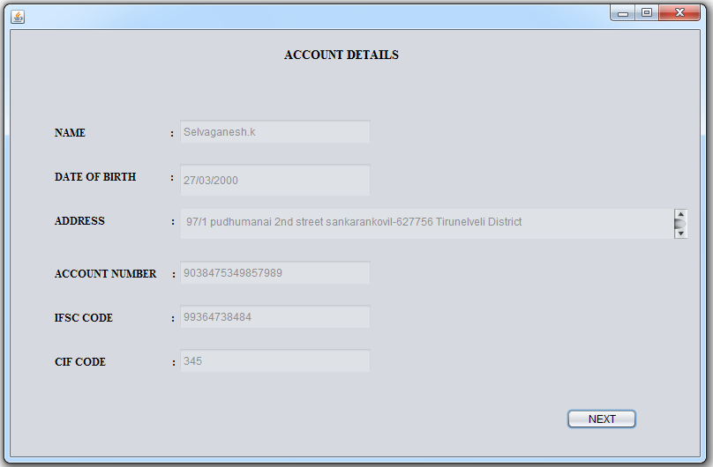

FIGURE 5.4

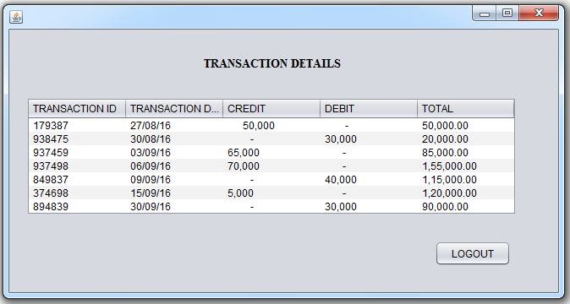

FIGURE 5.5

**CHAPTER 6**

**CONCLUSION:**

* This application is very useful for the people who always use banking for their transactions.
* It is very easy to know about the banking details, otherwise we need to go to the bank to get the details that will affect the time .
* By having in your place we can get the banking details .

**FUTURE WORK:**

* The future outlook of this work is to make the application web-enabled, which would greatly enhance its use.
* Users could then access the application from anywhere via the Internet, and be able to carry out their work, and students with proper authorization would be able to view their results online.

**APPENDICES**

**JAVA SOURCE CODE**

**MANAGER LOGIN**

import java.sql.*;

import javax.swing.JOptionPane;

public class login extends javax.swing.JFrame {

public login() {

initComponents(); }

private void initComponents() {

jPanel1 = new javax.swing.JPanel();

jLabel1 = new javax.swing.JLabel();

jLabel2 = new javax.swing.JLabel();

jLabel3 = new javax.swing.JLabel();

txt_username = new javax.swing.JTextField();

txt_password = new javax.swing.JPasswordField();

login = new javax.swing.JButton();

reset = new javax.swing.JButton();

setDefaultCloseOperation(javax.swing.WindowConstants.EXIT_ON_CLOSE);

jPanel1.setLayout(null);

jLabel1.setFont(new java.awt.Font("Times New Roman", 1, 24)); // NOI18N

jLabel1.setText("BANKING SYSTEM");

jPanel1.add(jLabel1);

jLabel1.setBounds(130, 30, 220, 20);

jLabel2.setFont(new java.awt.Font("Times New Roman", 0, 16)); // NOI18N

jLabel2.setText("username:");

jPanel1.add(jLabel2);

jLabel2.setBounds(30, 120, 70, 20);

jLabel3.setFont(new java.awt.Font("Times New Roman", 0, 16)); // NOI18N

jLabel3.setText("password:");

jPanel1.add(jLabel3);

jLabel3.setBounds(30, 200, 70, 20);

jPanel1.add(txt_username);

txt_username.setBounds(120, 120, 230, 30);

jPanel1.add(txt_password);

txt_password.setBounds(120, 200, 230, 30);

login.setText("LOGIN");

login.addActionListener(new java.awt.event.ActionListener() {

public void actionPerformed(java.awt.event.ActionEvent evt) {

loginActionPerformed(evt);

}

});

jPanel1.add(login);

login.setBounds(120, 290, 80, 23);

reset.setText("RESET");

reset.addActionListener(new java.awt.event.ActionListener() {

public void actionPerformed(java.awt.event.ActionEvent evt) {

resetActionPerformed(evt);

}

});

jPanel1.add(reset);

reset.setBounds(273, 290, 80, 23);

javax.swing.GroupLayout layout = new javax.swing.GroupLayout(getContentPane());

getContentPane().setLayout(layout);

layout.setHorizontalGroup(

layout.createParallelGroup(javax.swing.GroupLayout.Alignment.LEADING)

.addComponent(jPanel1, javax.swing.GroupLayout.PREFERRED_SIZE, 430, javax.swing.GroupLayout.PREFERRED_SIZE)

);

layout.setVerticalGroup(

layout.createParallelGroup(javax.swing.GroupLayout.Alignment.LEADING)

.addComponent(jPanel1, javax.swing.GroupLayout.PREFERRED_SIZE, 355, javax.swing.GroupLayout.PREFERRED_SIZE)

);

pack();

}

private void loginActionPerformed(java.awt.event.ActionEvent evt) {

String s1=txt_username.getText();

String s2=new String(txt_password.getPassword());

try

{

Class.forName("com.mysql.jdbc.Driver");

Connection con=DriverManager.getConnection("jdbc:mysql://localhost:3306/bank","root","root");

Statement stmt=con.createStatement();

String query="select * from login where userid='"+s1+"' and passwd='"+s2+"'";

ResultSet rs=stmt.executeQuery(query);

if(rs.next())

{

JOptionPane.showMessageDialog(null,"username and password matched");

userlogin u=new userlogin();

u.setVisible(true);

this.dispose();

}

else

{

JOptionPane.showMessageDialog(null,"username and password not match");

System.exit(0);

}

}

catch(Exception ex)

{

JOptionPane.showMessageDialog(null,"login failed");

}

}

private void resetActionPerformed(java.awt.event.ActionEvent evt) {

txt_username.setText("");

txt_password.setText("");

}

public static void main(String args[]) {

try {

for (javax.swing.UIManager.LookAndFeelInfo info : javax.swing.UIManager.getInstalledLookAndFeels()) {

if ("Nimbus".equals(info.getName())) {

javax.swing.UIManager.setLookAndFeel(info.getClassName());

break;

}

}

} catch (ClassNotFoundException ex) {

java.util.logging.Logger.getLogger(login.class.getName()).log(java.util.logging.Level.SEVERE, null, ex);

} catch (InstantiationException ex) {

java.util.logging.Logger.getLogger(login.class.getName()).log(java.util.logging.Level.SEVERE, null, ex);

} catch (IllegalAccessException ex) {

java.util.logging.Logger.getLogger(login.class.getName()).log(java.util.logging.Level.SEVERE, null, ex);

} catch (javax.swing.UnsupportedLookAndFeelException ex) {

java.util.logging.Logger.getLogger(login.class.getName()).log(java.util.logging.Level.SEVERE, null, ex);

}

java.awt.EventQueue.invokeLater(new Runnable() {

public void run() {

new login().setVisible(true);

}

});

}

private javax.swing.JLabel jLabel1;

private javax.swing.JLabel jLabel2;

private javax.swing.JLabel jLabel3;

private javax.swing.JPanel jPanel1;

private javax.swing.JButton login;

private javax.swing.JButton reset;

private javax.swing.JPasswordField txt_password;

private javax.swing.JTextField txt_username;

}

**USER LOGIN:**

import java.sql.*;

import javax.swing.JOptionPane;

public class userlogin extends javax.swing.JFrame {

public userlogin() {

initComponents();

}

private void initComponents() {

jPanel1 = new javax.swing.JPanel();

jLabel1 = new javax.swing.JLabel();

jLabel2 = new javax.swing.JLabel();

jLabel3 = new javax.swing.JLabel();

accountnumber = new javax.swing.JTextField();

ifsccode = new javax.swing.JTextField();

login = new javax.swing.JButton();

reset = new javax.swing.JButton();

setDefaultCloseOperation(javax.swing.WindowConstants.EXIT_ON_CLOSE);

jPanel1.setLayout(null);

jLabel1.setFont(new java.awt.Font("Times New Roman", 0, 14)); // NOI18N

jLabel1.setText("ACCOUNT LOGIN");

jPanel1.add(jLabel1);

jLabel1.setBounds(200, 30, 120, 17);

jLabel2.setFont(new java.awt.Font("Times New Roman", 0, 12)); // NOI18N

jLabel2.setText("ACCOUNT NUMBER:");

jPanel1.add(jLabel2);

jLabel2.setBounds(20, 120, 130, 14);

jLabel3.setFont(new java.awt.Font("Times New Roman", 0, 12)); // NOI18N

jLabel3.setText("IFSC CODE:");

jPanel1.add(jLabel3);

jLabel3.setBounds(30, 200, 90, 14);

jPanel1.add(accountnumber);

accountnumber.setBounds(160, 110, 290, 30);

jPanel1.add(ifsccode);

ifsccode.setBounds(160, 190, 290, 30);

login.setText("LOGIN");

login.addActionListener(new java.awt.event.ActionListener() {

public void actionPerformed(java.awt.event.ActionEvent evt) {

loginActionPerformed(evt);

}

});

jPanel1.add(login);

login.setBounds(160, 260, 80, 30);

reset.setText("RESET");

reset.addActionListener(new java.awt.event.ActionListener() {

public void actionPerformed(java.awt.event.ActionEvent evt) {

resetActionPerformed(evt);

}

});

jPanel1.add(reset);

reset.setBounds(363, 260, 80, 23);

javax.swing.GroupLayout layout = new javax.swing.GroupLayout(getContentPane());

getContentPane().setLayout(layout);

layout.setHorizontalGroup(

layout.createParallelGroup(javax.swing.GroupLayout.Alignment.LEADING)

.addComponent(jPanel1, javax.swing.GroupLayout.PREFERRED_SIZE, 502, javax.swing.GroupLayout.PREFERRED_SIZE)

);

layout.setVerticalGroup(

layout.createParallelGroup(javax.swing.GroupLayout.Alignment.LEADING)

.addComponent(jPanel1, javax.swing.GroupLayout.PREFERRED_SIZE, 318, javax.swing.GroupLayout.PREFERRED_SIZE)

);

pack();

}

private void loginActionPerformed(java.awt.event.ActionEvent evt) {

String s1=accountnumber.getText();

String s2=ifsccode.getText();

Accountdetails a = new Accountdetails();

boolean flag = false;

try

{

Class.forName("com.mysql.jdbc.Driver");

Connection con=DriverManager.getConnection("jdbc:mysql://localhost:3306/bank","root","root");

Statement stmt=con.createStatement();

String query="select * from userlogin where accno='"+s1+"' and ifsc='"+s2+"'";

ResultSet rs=stmt.executeQuery(query);

while(rs.next())

{

flag = true;

JOptionPane.showMessageDialog(null,"valid user");

Accountdetails t=new Accountdetails();

t.setVisible(true);

this.dispose();

String query1="select * from accdetails";

ResultSet rs1=stmt.executeQuery(query1);

while(rs1.next())

{

System.out.println(rs1.getString(1));

Accountdetails.name.setText(rs1.getString(1));

System.out.println(rs1.getString(2));

Accountdetails.dob.setText(rs1.getString(2));

System.out.println(rs1.getString(3));

Accountdetails.address.setText(rs1.getString(3));

System.out.println(rs1.getString(4));

Accountdetails.accnumber.setText(rs1.getString(4));

System.out.println(rs1.getString(5));

Accountdetails.ifsc.setText(rs1.getString(5));

System.out.println(rs1.getString(6));

Accountdetails.cif.setText(rs1.getString(6));

}

}

if(flag)

{

JOptionPane.showMessageDialog(null,"invalid user");

}

}

catch(Exception ex)

{

}

}

private void resetActionPerformed(java.awt.event.ActionEvent evt) {

accountnumber.setText("");

ifsccode.setText("");

}

public static void main(String args[]) {

java.awt.EventQueue.invokeLater(new Runnable() {

public void run() {

new userlogin().setVisible(true);

}

});

}

private javax.swing.JTextField accountnumber;

private javax.swing.JTextField ifsccode;

private javax.swing.JLabel jLabel1;

private javax.swing.JLabel jLabel2;

private javax.swing.JLabel jLabel3;

private javax.swing.JPanel jPanel1;

private javax.swing.JButton login;

private javax.swing.JButton reset;

}

**ACCOUNT DETAILS**

import java.sql.*;

import javax.swing.JOptionPane;

public class Accountdetails extends javax.swing.JFrame {

public Accountdetails() {

initComponents();

}

@SuppressWarnings("unchecked")

private void initComponents() {

jPanel1 = new javax.swing.JPanel();

jLabel1 = new javax.swing.JLabel();

jLabel2 = new javax.swing.JLabel();

jLabel3 = new javax.swing.JLabel();

jLabel4 = new javax.swing.JLabel();

jLabel5 = new javax.swing.JLabel();

jLabel6 = new javax.swing.JLabel();

jLabel7 = new javax.swing.JLabel();

next = new javax.swing.JButton();

name = new javax.swing.JTextField();

dob = new javax.swing.JTextField();

cif = new javax.swing.JTextField();

accnumber = new javax.swing.JTextField();

ifsc = new javax.swing.JTextField();

jScrollPane1 = new javax.swing.JScrollPane();

address = new javax.swing.JTextArea();

setDefaultCloseOperation(javax.swing.WindowConstants.EXIT_ON_CLOSE);

jPanel1.setLayout(null);

jLabel1.setFont(new java.awt.Font("Times New Roman", 1, 12)); // NOI18N

jLabel1.setText("NAME :");

jPanel1.add(jLabel1);

jLabel1.setBounds(50, 110, 140, 14);

jLabel2.setFont(new java.awt.Font("Times New Roman", 1, 12)); // NOI18N

jLabel2.setText("DATE OF BIRTH :");

jPanel1.add(jLabel2);

jLabel2.setBounds(50, 160, 140, 14);

jLabel3.setFont(new java.awt.Font("Times New Roman", 1, 14)); // NOI18N

jLabel3.setText("ACCOUNT DETAILS");

jPanel1.add(jLabel3);

jLabel3.setBounds(310, 20, 140, 17);

jLabel4.setFont(new java.awt.Font("Times New Roman", 1, 12)); // NOI18N

jLabel4.setText("ADDRESS :");

jPanel1.add(jLabel4);

jLabel4.setBounds(50, 210, 140, 14);

jLabel5.setFont(new java.awt.Font("Times New Roman", 1, 12)); // NOI18N

jLabel5.setText("ACCOUNT NUMBER :");

jPanel1.add(jLabel5);

jLabel5.setBounds(50, 270, 140, 14);

jLabel6.setFont(new java.awt.Font("Times New Roman", 1, 12)); // NOI18N

jLabel6.setText("IFSC CODE :");

jPanel1.add(jLabel6);

jLabel6.setBounds(50, 320, 136, 14);

jLabel7.setFont(new java.awt.Font("Times New Roman", 1, 12)); // NOI18N

jLabel7.setText("CIF CODE :");

jPanel1.add(jLabel7);

jLabel7.setBounds(50, 370, 140, 14);

next.setText("NEXT");

next.addActionListener(new java.awt.event.ActionListener() {

public void actionPerformed(java.awt.event.ActionEvent evt) {

nextActionPerformed(evt);

}

});

jPanel1.add(next);

next.setBounds(630, 430, 80, 23);

name.setEnabled(false);

jPanel1.add(name);

name.setBounds(190, 100, 220, 30);

dob.setEnabled(false);

dob.addActionListener(new java.awt.event.ActionListener() {

public void actionPerformed(java.awt.event.ActionEvent evt) {

dobActionPerformed(evt);

}

});

jPanel1.add(dob);

dob.setBounds(190, 150, 220, 40);

cif.setEnabled(false);

jPanel1.add(cif);

cif.setBounds(190, 360, 220, 30);

accnumber.setEnabled(false);

accnumber.addActionListener(new java.awt.event.ActionListener() {

public void actionPerformed(java.awt.event.ActionEvent evt) {

accnumberActionPerformed(evt);

}

});

jPanel1.add(accnumber);

accnumber.setBounds(190, 260, 220, 30);

ifsc.setEnabled(false);

jPanel1.add(ifsc);

ifsc.setBounds(190, 310, 220, 30);

jScrollPane1.setEnabled(false);

address.setColumns(20);

address.setRows(5);

address.setEnabled(false);

jScrollPane1.setViewportView(address);

jPanel1.add(jScrollPane1);

jScrollPane1.setBounds(190, 200, 580, 40);

javax.swing.GroupLayout layout = new javax.swing.GroupLayout(getContentPane());

getContentPane().setLayout(layout);

layout.setHorizontalGroup(

layout.createParallelGroup(javax.swing.GroupLayout.Alignment.LEADING)

.addComponent(jPanel1, javax.swing.GroupLayout.PREFERRED_SIZE, 781, javax.swing.GroupLayout.PREFERRED_SIZE)

);

layout.setVerticalGroup(

layout.createParallelGroup(javax.swing.GroupLayout.Alignment.LEADING)

.addComponent(jPanel1, javax.swing.GroupLayout.DEFAULT_SIZE, 484, Short.MAX_VALUE)

);

pack();

}// </editor-fold>

private void nextActionPerformed(java.awt.event.ActionEvent evt) {

// TODO add your handling code here:

Transactiondetails o=new Transactiondetails();

o.setVisible(true);

this.dispose();

}

private void dobActionPerformed(java.awt.event.ActionEvent evt) {

// TODO add your handling code here:

}

private void accnumberActionPerformed(java.awt.event.ActionEvent evt) {

// TODO add your handling code here:

}

public static void main(String args[]) {

try {

for (javax.swing.UIManager.LookAndFeelInfo info : javax.swing.UIManager.getInstalledLookAndFeels()) {

if ("Nimbus".equals(info.getName())) {

javax.swing.UIManager.setLookAndFeel(info.getClassName());

break;

}

}

} catch (ClassNotFoundException ex) {

java.util.logging.Logger.getLogger(Accountdetails.class.getName()).log(java.util.logging.Level.SEVERE, null, ex);

} catch (InstantiationException ex) {

java.util.logging.Logger.getLogger(Accountdetails.class.getName()).log(java.util.logging.Level.SEVERE, null, ex);

} catch (IllegalAccessException ex) {

java.util.logging.Logger.getLogger(Accountdetails.class.getName()).log(java.util.logging.Level.SEVERE, null, ex);

} catch (javax.swing.UnsupportedLookAndFeelException ex) {

java.util.logging.Logger.getLogger(Accountdetails.class.getName()).log(java.util.logging.Level.SEVERE, null, ex);

}

java.awt.EventQueue.invokeLater(new Runnable() {

public void run() {

new Accountdetails().setVisible(true);

}

}

});

}

// Variables declaration - do not modify

public static javax.swing.JTextField accnumber;

public static javax.swing.JTextArea address;

public static javax.swing.JTextField cif;

public static javax.swing.JTextField dob;

public static javax.swing.JTextField ifsc;

private javax.swing.JLabel jLabel1;

private javax.swing.JLabel jLabel2;

private javax.swing.JLabel jLabel3;

private javax.swing.JLabel jLabel4;

private javax.swing.JLabel jLabel5;

private javax.swing.JLabel jLabel6;

private javax.swing.JLabel jLabel7;

private javax.swing.JPanel jPanel1;

private javax.swing.JScrollPane jScrollPane1;

public static javax.swing.JTextField name;

private javax.swing.JButton next;

// End of variables declaration

}

**TRANSACTION DETAILS**

public class Transactiondetails extends javax.swing.JFrame {

public Transactiondetails() {

initComponents();

}

@SuppressWarnings("unchecked")

private void initComponents() {

jLabel2 = new javax.swing.JLabel();

jScrollPane1 = new javax.swing.JScrollPane();

trans = new javax.swing.JTable();

setDefaultCloseOperation(javax.swing.WindowConstants.EXIT_ON_CLOSE);

getContentPane().setLayout(null);

jLabel2.setFont(new java.awt.Font("Times New Roman", 1, 14)); // NOI18N

jLabel2.setText("TRANSACTION DETAILS");

getContentPane().add(jLabel2);

jLabel2.setBounds(230, 30, 170, 20);

trans.setModel(new javax.swing.table.DefaultTableModel(

new Object [][] {

{"179387", "27/08/16", " 50,000", " -", "50,000.00"},

{"938475", "30/08/16", " -", "30,000", "20,000.00"},

{"937459", "03/09/16", "65,000", " -", "85,000.00"},

{"937498", "06/09/16", "70,000", " -", "1,55,000.00"},

{"849837", "09/09/16", " -", "40,000", "1,15,000.00"},

{"374698", "15/09/16", "5,000", " -", "1,20,000.00"},

{"894839", "30/09/16", " -", "30,000", "90,000.00"}

},

new String [] {

"TRANSACTION ID", "TRANSACTION DATE", "CREDIT", "DEBIT", "TOTAL"

}

) {

Class[] types = new Class [] {

java.lang.String.class, java.lang.String.class, java.lang.String.class, java.lang.String.class, java.lang.String.class

};

public Class getColumnClass(int columnIndex) {

return types [columnIndex];

}

});

jScrollPane1.setViewportView(trans);

getContentPane().add(jScrollPane1);

jScrollPane1.setBounds(20, 80, 580, 140);

pack();

}

public static void main(String args[]) {

try {

for (javax.swing.UIManager.LookAndFeelInfo info : javax.swing.UIManager.getInstalledLookAndFeels()) {

if ("Nimbus".equals(info.getName())) {

javax.swing.UIManager.setLookAndFeel(info.getClassName());

break;

}

}

} catch (ClassNotFoundException ex) {

java.util.logging.Logger.getLogger(Transactiondetails.class.getName()).log(java.util.logging.Level.SEVERE, null, ex);

} catch (InstantiationException ex) {

java.util.logging.Logger.getLogger(Transactiondetails.class.getName()).log(java.util.logging.Level.SEVERE, null, ex);

} catch (IllegalAccessException ex) {

java.util.logging.Logger.getLogger(Transactiondetails.class.getName()).log(java.util.logging.Level.SEVERE, null, ex);

} catch (javax.swing.UnsupportedLookAndFeelException ex) {

java.util.logging.Logger.getLogger(Transactiondetails.class.getName()).log(java.util.logging.Level.SEVERE, null, ex);

}

java.awt.EventQueue.invokeLater(new Runnable() {

public void run() {

new Transactiondetails().setVisible(true);

}

});

}

private javax.swing.JLabel jLabel2;

private javax.swing.JScrollPane jScrollPane1;

public static javax.swing.JTable trans;

// End of variables declaration

}

**REGISTER**

import java.sql.*;

import javax.swing.JOptionPane;

public class register extends javax.swing.JFrame {

**public register() {**

**initComponents();**

@SuppressWarnings("unchecked")

// <editor-fold defaultstate="collapsed" desc="Generated Code">

private void initComponents() {

jPanel1 = new javax.swing.JPanel();

jLabel1 = new javax.swing.JLabel();

jLabel2 = new javax.swing.JLabel();

jLabel3 = new javax.swing.JLabel();

jLabel4 = new javax.swing.JLabel();

jLabel5 = new javax.swing.JLabel();

jLabel6 = new javax.swing.JLabel();

jLabel7 = new javax.swing.JLabel();

address = new javax.swing.JTextField();

ifsc = new javax.swing.JTextField();

name2 = new javax.swing.JTextField();

phoneno = new javax.swing.JTextField();

accno = new javax.swing.JTextField();

dob = new javax.swing.JTextField();

cancel = new javax.swing.JButton();

reset = new javax.swing.JButton();

create = new javax.swing.JButton();

jLabel8 = new javax.swing.JLabel();

cif = new javax.swing.JTextField();

setDefaultCloseOperation(javax.swing.WindowConstants.EXIT_ON_CLOSE);

jPanel1.setLayout(null);

jLabel1.setFont(new java.awt.Font("Times New Roman", 1, 18)); // NOI18N

jLabel1.setText("CREATE NEW ACCOUNT");

jPanel1.add(jLabel1);

jLabel1.setBounds(250, 30, 240, 40);

jLabel2.setFont(new java.awt.Font("Times New Roman", 1, 12)); // NOI18N

jLabel2.setText("NAME :");

jPanel1.add(jLabel2);

jLabel2.setBounds(50, 110, 140, 14);

jLabel3.setFont(new java.awt.Font("Times New Roman", 1, 12)); // NOI18N

jLabel3.setText("DATE OF BIRTH :");

jPanel1.add(jLabel3);

jLabel3.setBounds(50, 160, 140, 14);

jLabel4.setFont(new java.awt.Font("Times New Roman", 1, 12)); // NOI18N

jLabel4.setText("ADDRESS :");

jPanel1.add(jLabel4);

jLabel4.setBounds(50, 210, 140, 14);

jLabel5.setFont(new java.awt.Font("Times New Roman", 1, 12)); // NOI18N

jLabel5.setText("ACCOUNT NUMBER :");

jPanel1.add(jLabel5);

jLabel5.setBounds(50, 270, 140, 14);

jLabel6.setFont(new java.awt.Font("Times New Roman", 1, 12)); // NOI18N

jLabel6.setText("IFSC CODE :");

jPanel1.add(jLabel6);

jLabel6.setBounds(50, 320, 136, 14);

jLabel7.setFont(new java.awt.Font("Times New Roman", 1, 12)); // NOI18N

jLabel7.setText("PHONE NO :");

jPanel1.add(jLabel7);

jLabel7.setBounds(50, 430, 140, 14);

jPanel1.add(address);

address.setBounds(210, 200, 490, 30);

jPanel1.add(ifsc);

ifsc.setBounds(210, 310, 490, 30);

jPanel1.add(name2);

name2.setBounds(210, 100, 490, 30);

phoneno.setText("+91");

jPanel1.add(phoneno);

phoneno.setBounds(210, 420, 490, 30);

jPanel1.add(accno);

accno.setBounds(210, 260, 490, 30);

jPanel1.add(dob);

dob.setBounds(210, 150, 490, 30);

cancel.setText("CANCEL");

cancel.addActionListener(new java.awt.event.ActionListener() {

public void actionPerformed(java.awt.event.ActionEvent evt) {

cancelActionPerformed(evt);

}

});

jPanel1.add(cancel);

cancel.setBounds(560, 500, 140, 40);

reset.setText("RESET");

reset.addActionListener(new java.awt.event.ActionListener() {

public void actionPerformed(java.awt.event.ActionEvent evt) {

resetActionPerformed(evt);

}

});

jPanel1.add(reset);

reset.setBounds(390, 500, 140, 40);

create.setText("CREATE");

create.addActionListener(new java.awt.event.ActionListener() {

public void actionPerformed(java.awt.event.ActionEvent evt) {

createActionPerformed(evt);

}

});

jPanel1.add(create);

create.setBounds(220, 500, 140, 40);

jLabel8.setFont(new java.awt.Font("Times New Roman", 1, 12)); // NOI18N

jLabel8.setText("CIF CODE :");

jPanel1.add(jLabel8);

jLabel8.setBounds(50, 370, 140, 14);

jPanel1.add(cif);

cif.setBounds(210, 360, 490, 30);

javax.swing.GroupLayout layout = new javax.swing.GroupLayout(getContentPane());

getContentPane().setLayout(layout);

layout.setHorizontalGroup(

layout.createParallelGroup(javax.swing.GroupLayout.Alignment.LEADING)

.addComponent(jPanel1, javax.swing.GroupLayout.DEFAULT_SIZE, 776, Short.MAX_VALUE)

);

layout.setVerticalGroup(

layout.createParallelGroup(javax.swing.GroupLayout.Alignment.LEADING)

.addComponent(jPanel1, javax.swing.GroupLayout.DEFAULT_SIZE, 576, Short.MAX_VALUE)

);

pack();

}// </editor-fold>

private void resetActionPerformed(java.awt.event.ActionEvent evt) {

// TODO add your handling code here:

name2.setText("");

dob.setText("");

address.setText("");

accno.setText("");

ifsc.setText("");

cif.setText("");

phoneno.setText("");

}

private void cancelActionPerformed(java.awt.event.ActionEvent evt) {

// TODO add your handling code here:

userlogin u=new userlogin();

u.setVisible(true);

this.dispose();

}

private void createActionPerformed(java.awt.event.ActionEvent evt) {

// TODO add your handling code here:

String s1=name2.getText();

String s2=dob.getText();

String s3=address.getText();

String s4=accno.getText();

String s5=ifsc.getText();

String s6=cif.getText();

String s7=phoneno.getText();

try

{

Class.forName("com.mysql.jdbc.Driver");

Connection con=DriverManager.getConnection("jdbc:mysql://localhost:3306/bank","root","root");

Statement stmt=con.createStatement();

stmt.executeUpdate("insert into accdetails values('"+s1+"','"+s2+"','"+s3+"','"+s4+"','"+s5+"','"+s6+"','"+s7+"')");

JOptionPane.showMessageDialog(null,"created successfully");

}

catch(Exception ex)

{

JOptionPane.showMessageDialog(null,"failed");

}

}

/**

* @param args the command line arguments

*/

public static void main(String args[]) {

/* Set the Nimbus look and feel */

//<editor-fold defaultstate="collapsed" desc=" Look and feel setting code (optional) ">

/* If Nimbus (introduced in Java SE 6) is not available, stay with the default look and feel.

* For details see http://download.oracle.com/javase/tutorial/uiswing/lookandfeel/plaf.html

*/

try {

for (javax.swing.UIManager.LookAndFeelInfo info : javax.swing.UIManager.getInstalledLookAndFeels()) {

if ("Nimbus".equals(info.getName())) {

javax.swing.UIManager.setLookAndFeel(info.getClassName());

break;

}

}

} catch (ClassNotFoundException ex) {

java.util.logging.Logger.getLogger(register.class.getName()).log(java.util.logging.Level.SEVERE, null, ex);

} catch (InstantiationException ex) {

java.util.logging.Logger.getLogger(register.class.getName()).log(java.util.logging.Level.SEVERE, null, ex);

} catch (IllegalAccessException ex) {

java.util.logging.Logger.getLogger(register.class.getName()).log(java.util.logging.Level.SEVERE, null, ex);

} catch (javax.swing.UnsupportedLookAndFeelException ex) {

java.util.logging.Logger.getLogger(register.class.getName()).log(java.util.logging.Level.SEVERE, null, ex);

}

//</editor-fold>

/* Create and display the form */

java.awt.EventQueue.invokeLater(new Runnable() {

public void run() {

new register().setVisible(true);

}

});

}

// Variables declaration - do not modify

private javax.swing.JTextField accno;

private javax.swing.JTextField address;

private javax.swing.JButton cancel;

private javax.swing.JTextField cif;

private javax.swing.JButton create;

private javax.swing.JTextField dob;

private javax.swing.JTextField ifsc;

private javax.swing.JLabel jLabel1;

private javax.swing.JLabel jLabel2;

private javax.swing.JLabel jLabel3;

private javax.swing.JLabel jLabel4;

private javax.swing.JLabel jLabel5;

private javax.swing.JLabel jLabel6;

private javax.swing.JLabel jLabel7;

private javax.swing.JLabel jLabel8;

private javax.swing.JPanel jPanel1;

private javax.swing.JTextField name2;

private javax.swing.JTextField phoneno;

private javax.swing.JButton reset;

// End of variables declaration

}

**REFERENCES:**

* [https://www.scu.edu.au](https://www.scu.edu.au/)
* <https://degreeprogress.ku.edu/gpa>